Eastern State Penitentiary Transportation Reimbursement Scholarship

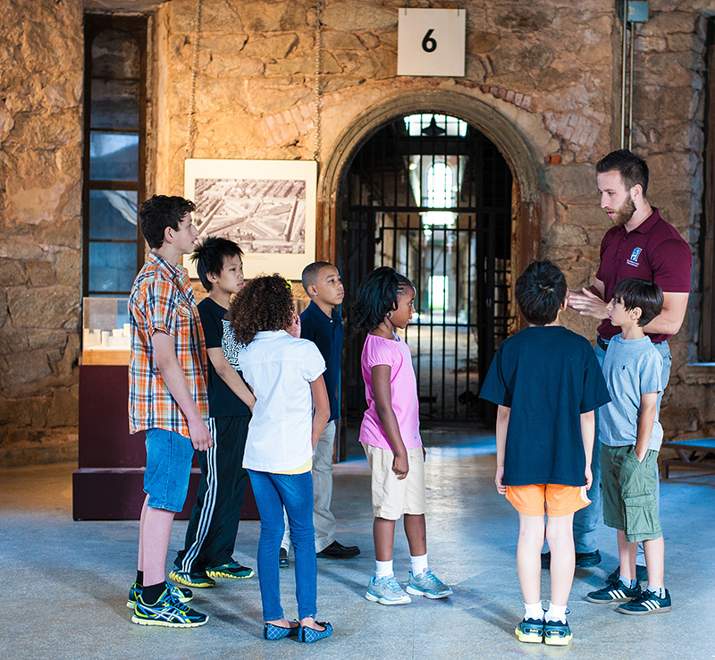
Eastern State Penitentiary offers scholarships to reimburse the cost of transportation (up to $200) for qualifying schools. Scholarships will be awarded on a first-come, first-served basis through December 2017. Because funding is limited, we encourage you to apply early. Scholarships will only cover bus or Southeastern Pennsylvania Transportation Authority (SEPTA) transportation cost. Guided tours and admission for Philadelphia public and charter schools are always free.

Eligibility Guidelines:
- 51% of the student population must qualify for free or reduced-price lunches through the National School Lunch Program.
- Schools within the Philadelphia School District are given priority.

Reimbursement Guidelines:
- Eastern State Penitentiary will reimburse your school by check. Eastern State Penitentiary will not pay the bus company or SEPTA directly.
- Your school must handle all transportation logistics. These logistics include:
  - For Buses: contacting a bus company, scheduling a bus, and/or communicating to the bus company the pick-up and drop-off times and locations.
  - For SEPTA: planning route, deciding mode of transportation, and token/ticket purchasing. For more information regarding SEPTA, visit http://www.septa.org/.

- In order for your school to be reimbursed, a copy of the paid in full bus invoice or SEPTA token receipt must be presented upon arrival or received by December 31, 2017.
- If the school cancels the field trip and fails to cancel the transportation arrangement, the school will be responsible for any transportation cancellation fees/penalties or the cost of the transportation.

How to Apply:
- After booking your trip, complete the attached Transportation Reimbursement Scholarship Application. The school principal and the participating teacher must sign the application.
- Applications must be received at least 2 weeks prior to the scheduled visit. Failure to submit the application in advance will disqualify the school from participating in the program.
- Eastern State Penitentiary will notify your school before your visit if the scholarship has been approved.
- Please email the completed application to Samantha Hunter at sh@easternstate.org. You may also mail applications to:
Eastern State Penitentiary
Attn: Transportation Scholarship
2027 Fairmount Avenue
Philadelphia, PA 19130

If you have questions please contact Samantha Hunter (Specialist, Education) at 215-236-5111 x220 or by email at sh@easternstate.org.

To book your trip please contact our Group Tour Department at 215-236-5111 x240, x210 or by email at grouptours@easternstate.org.

Transportation Reimbursement Scholarship Application
Eastern State Penitentiary

This application cannot be accepted without a confirmed field trip date. If you have not booked your trip, please contact our Group Tour Department at 215-236-5111 x210 or by email at grouptours@easternstate.org

Today’s Date: ___________________________

Confirmed Trip Date and Time: ___________________________

School Name: ___________________________________________________________________

School Phone: _____________________________________

School Mailing Address (where reimbursement should be sent): ___________________________________________________________________

___________________________________________________________________

Name on Reimbursement Check: _____________________________________

Amount to be Reimbursed: ____________________________________

Number of Students Attending: __________ Adults: __________ Grade: __________

Teacher Name: ___________________________________________________________________

Phone: _______________________________ Cell Phone: ______________________________

Email: _________________________________________

Percentage of students at your school that qualify for free or reduced price lunches: _________

Teacher Signature: ________________________________________ Date: _____________

Principal Signature: ________________________________________ Date: _____________

Email completed applications to Samantha Hunter (Specialist, Education): sh@easternstate.org

Or mail applications to:
Eastern State Penitentiary
Attn: Transportation Reimbursement Scholarship
2027 Fairmount Avenue
Philadelphia, PA 19130

